**Step-by-Step GitHub Workflow**

**✅ 1. Create a Repository on GitHub**

1. Go to <https://github.com>
2. Log in or sign up.
3. Click the **"+"** icon on the top-right corner → **"New repository"**
4. Enter:
   * Repository name
   * Description (optional)
   * Public or Private
5. Optionally initialize with a README.
6. Click **"Create repository"**

### 💻 ****2. Clone (Pull) the Repository to Local Machine****

This means you're downloading the repo to your system.

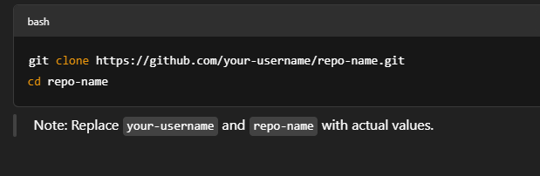

### 📂 ****3. Make Changes Locally****

Edit files or add new ones.

To add a new file:

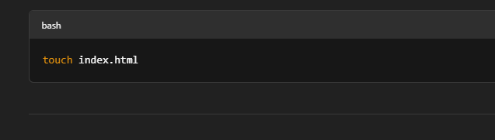

💾 **4. Stage and Commit Changes**

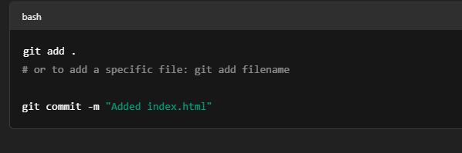

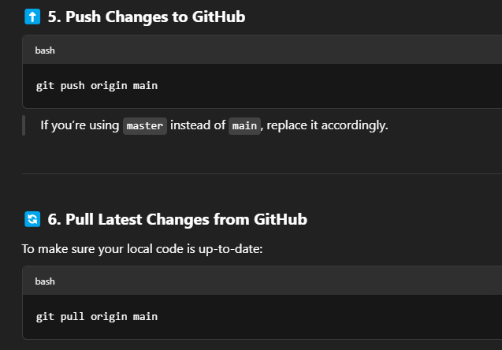

**🍴 7. Fork a Repository**

This copies someone else's repo to your GitHub account.

1. Go to the repo you want to fork (e.g., github.com/someone/repo)
2. Click the **"Fork"** button on the top-right
3. It will create a copy under your GitHub account

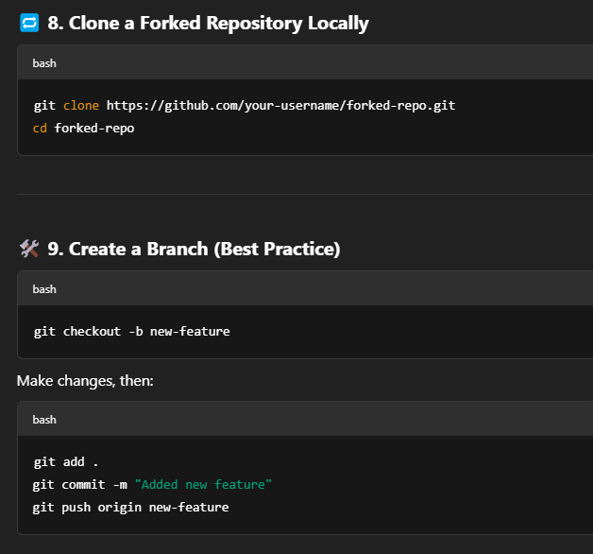

**📥 10. Create a Pull Request (PR) / Merge Request (MR)**

1. Go to your repository on GitHub
2. Click **"Compare & pull request"** (appears after pushing a new branch)
3. Add:
   * Title
   * Description of changes
4. Click **"Create pull request"**

**🔀 11. Merge a Pull Request**

(For repository owners or collaborators)

1. Go to the "Pull requests" tab
2. Open the PR
3. Review changes
4. Click **"Merge pull request"**
5. Then click **"Confirm merge"**

**🔁 12. Sync Your Fork with Original Repo (Optional)**

If the original repo has changed:

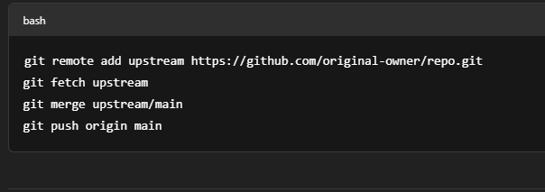

**Commands**

| **Task** | **Command** |
| --- | --- |
| Clone repo | git clone <url> |
| Create branch | git checkout -b <branch-name> |
| Add changes | git add . or git add <file> |
| Commit changes | git commit -m "message" |
| Push to GitHub | git push origin <branch-name> |
| Pull from GitHub | git pull origin <branch-name> |
| Merge from upstream | git merge upstream/main |

**Jenkins Jobs setup and Installation and Jobs creation**

[**https://medium.com/@mudasirhaji/complete-step-by-step-jenkins-cicd-with-github-integration-aae3961b6e33**](https://medium.com/@mudasirhaji/complete-step-by-step-jenkins-cicd-with-github-integration-aae3961b6e33)